Chris Trimmer

CS340 Client/Server

10/11/2023

Table of Contents

About the Project/Project Title 2

Motivation 2

Getting Started 2

Installation 2

Usage 5

Project Set Up 5

Running the application 10

Steps taken to complete the project 18

The Datatable 18

The Map 20

The Pie Chart 21

Challenges and explanations 23

Roadmap/Features (Optional) 25

Contact 25

References 26

## About the Project/Project Title

The purpose of this project is to implement an application programming interface (API) for our client, Grazioso Salvare. Grazioso Salvare is an international, rescue-animal training company who specializes in search-and-rescue dog training.

The application will consist of an interface supporting ‘Create, Read, Update, Delete’ (CRUD) operations on a MongoDB backing database. Users will be able to visualize and analyze data on a dashboard implemented using Dash. Dash is an interactive web-based application focused on supporting data visualization and analysis.

## Motivation

Grazioso Salvare requires an application that can interface with data from existing animal shelters in the Austin, Texas area. The data will be used to help them identify animals that may be good candidates for search-and-rescue training. Grazioso Salvare is motivated for this application so that they have a single interface for consuming data, rather than manually having to search five (or more) different systems.

We should also discuss why MongoDB and PyMongo were chosen for the project. MongoDB is arguably the most popular NoSQL database that exists. NoSQL databases are non-relational, and one of their main benefits is that they can store any type of data. For example, a NoSQL database can store images, arrays, emails, and just about any other type of data format.

PyMongo is a driver application that enables Python to interface with a MongoDB backing database. The main benefit of using PyMongo is that it works natively between MongoDB and Python, which means we do not need additional glue-ware for the two applications to interface with each other.

Dash is built on a Python framework, which makes it a natural choice for this type of application. Using Dash, we can design a dashboard composed of a variety of data analysis charts, graphs, and maps. Customers can interact with the dashboard using various components (buttons, input boxes, radio buttons, etc.) to analyze data.

## Getting Started

The following setup instructions will describe how to set up the project:

### Installation

The following are the primary application and tool requirements:

* MongoDB
  + MongoDB has a cloud option (MongoDB Atlas) that does not require installation on your home or work system (<https://www.mongodb.com/cloud/atlas/register>). There are paid and free options available for this service.
  + If installing on a Windows system, please follow these instructions: <https://www.mongodb.com/docs/manual/tutorial/install-mongodb-on-windows/> . Note: there is a community edition which is free.
  + If installing on a Linux system, please follow these instructions: <https://www.mongodb.com/docs/manual/administration/install-on-linux/> . Again, note that there is a community edition which is free.
* Python
  + Python can be installed on many different platforms. Please go to this location and follow the steps and links for your platform: <https://www.python.org/downloads/>
* PyMongo
  + PyMongo is a driver application that enables Python to interface with MongoDB databases. It basically translates Python code to instructions that MongoDB understands (and vice-versa). After you have installed Python, you can install PyMongo from command line by following instructions found here: <https://www.mongodb.com/docs/drivers/pymongo/>
* Dash
  + After you installed Python, you will need to install multiple libraries using the following commands:
    - Pip install dash
    - Pip install pandas
    - Pip install dash-leaflet
    - Pip install dash_bootstrap_components
    - Pip install plotly_express
  + Dash-leaflet is used for geo-mapping
  + Plotly_express is used for charts
* Creating the database and uploading the data
  + After installing all software, we can create the database and upload the Austin Animal Center (AAC) Outcomes data set. Note that the AAC data is in an excel .csv file. We name the database AAC, and the collection is named ‘animals’. (You can use any name of your choice.)

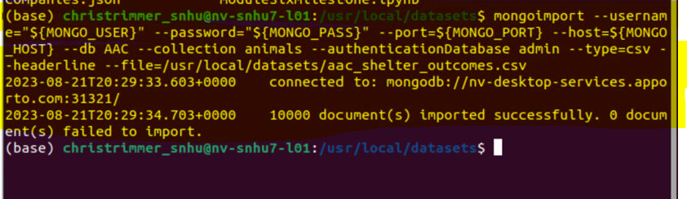

* + Next, log in to Mongo Shell using the mongosh command and verify the database and collection exists. (Note, the database should have 10000 documents.)

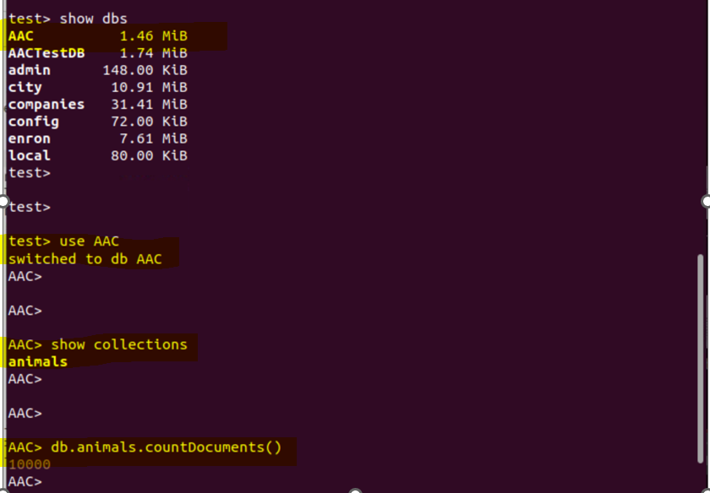

* Creating user accounts in MongoDB
  + An admin account is automatically created when MongoDB is initially created. It is highly recommended that user accounts are created with permissions and roles that pertain to how they will be using the database(s). Use Mongo shell and please follow the steps below for creating user accounts.
  + Begin by creating the account from the admin database when logged in as admin:

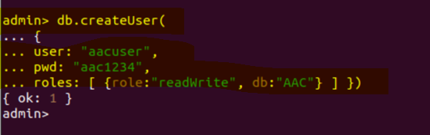

* + Verify the new user exists and can access the AAC database. Start from command line and update environment variables for the new account:

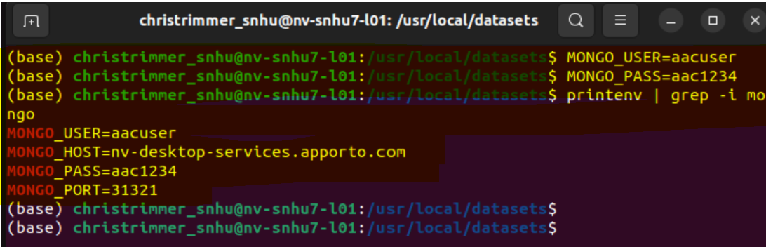

* + Go to Mongo shell using the new account and verify the connection status:

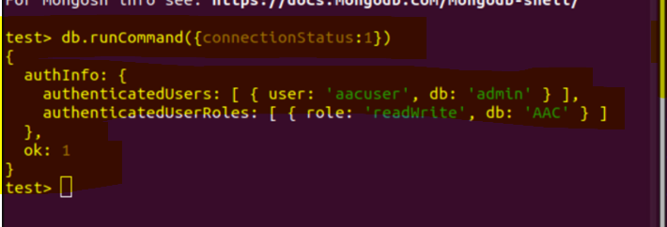

* + You should also verify that the new user can use the database:

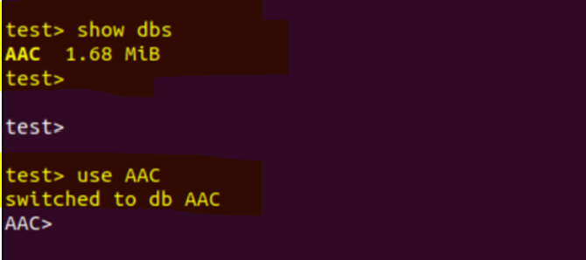

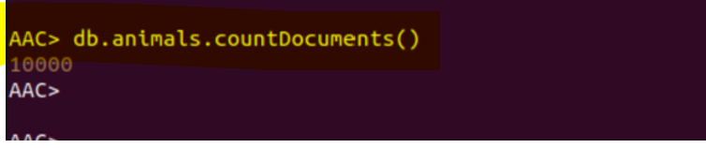

## Usage

The following code snippets and screenshots demonstrate how to use the application interface. At this time only the ‘Create’ and ‘Read’ operations are implemented.

### Project Set Up

* Begin by importing the CRUD library to your project, and instantiating an object instance that will be used for performing operations on the database. Following, that you can create objects using JSON pair/value notation as demonstrated below:

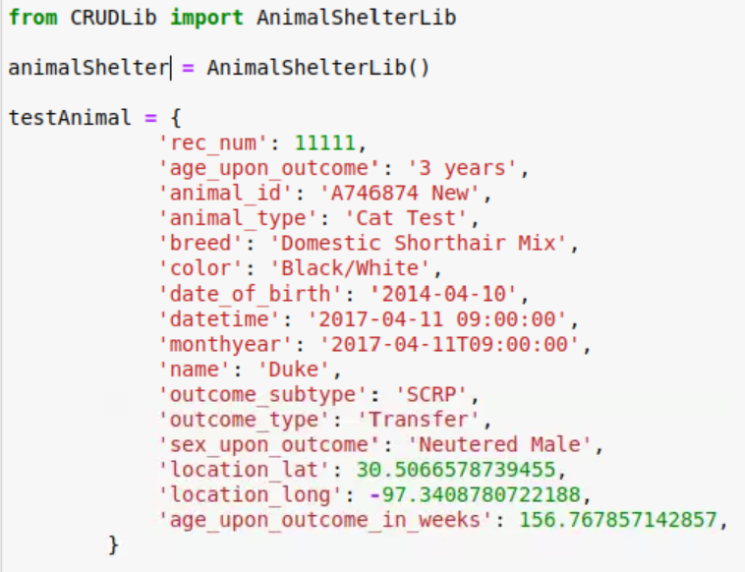

* Create
  + After the project is set up and you have created objects, you can use the Create function to add them to the database:



* + As a test, you can perform the creation using an if/else condition:

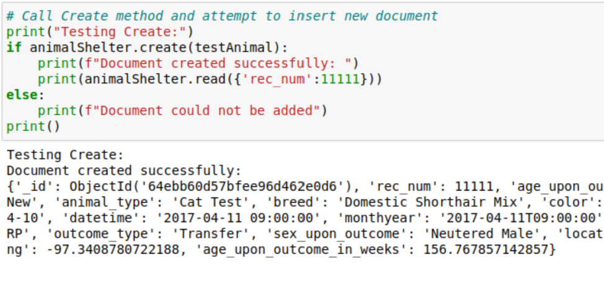

* + The following screenshot is the implementation of the create operation for your reference:

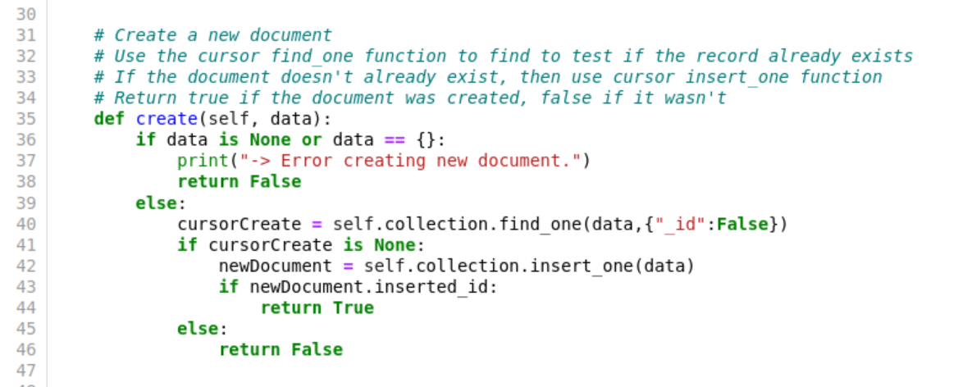

* Read
  + Reading from the database can be accomplished using a JSON pair/value format. You can also call the read method with empty notation to get all results from the data set. For this example, we will perform read on the test animal created earlier:

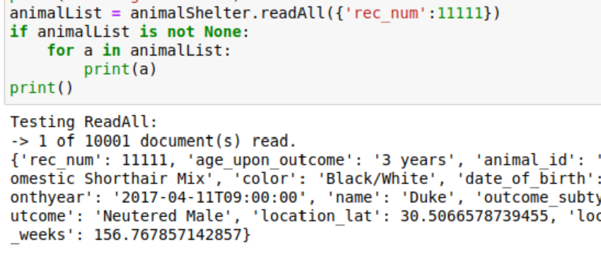

* + As a test, note that when specifying records in the read function, you will get specific results. If you perform a read on empty JSON, you will get all documents (all records not displayed in below screenshot to conserve on space). You should get a result like the below output that identifies how many documents are read. 10,000 records are inserted when you import the original data set, so this is the result you should see:

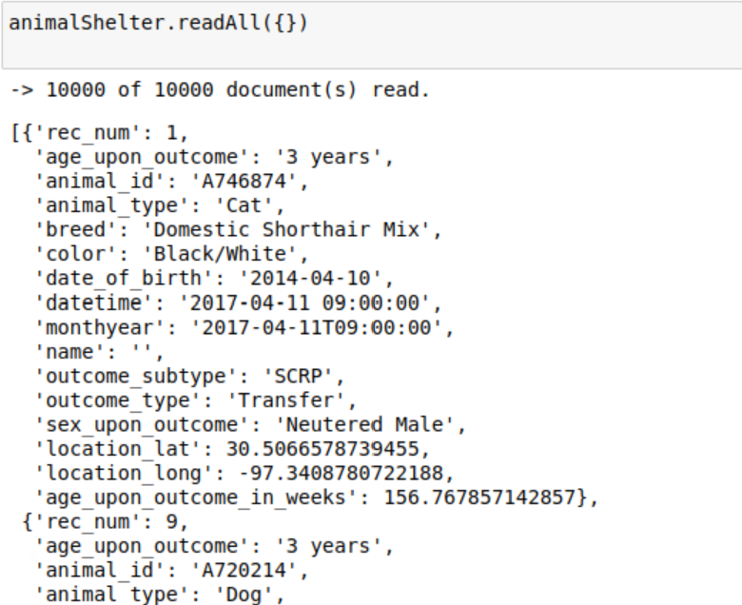

* + The following screenshot is the implementation of the read operation for your reference:

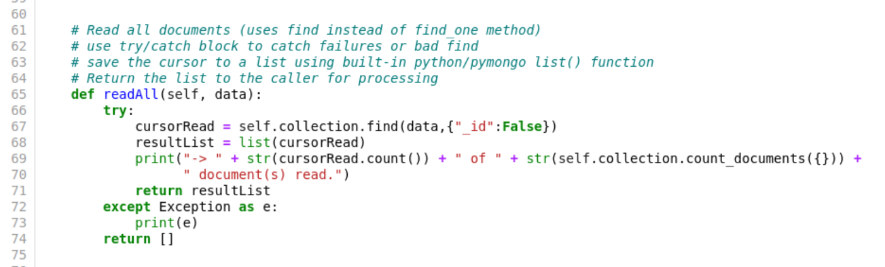

* Update
  + Updating from the database can be accomplished using JSON pair/value of document(s) that you want to update. The update operation will return an integer value, which is the number of documents modified. An example of performing an update is as follows:

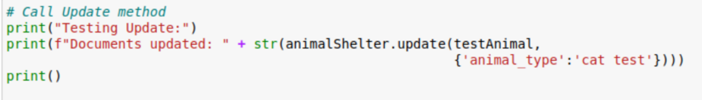

* + Verification of an update can be performed using a read on the object(s) that were modified. The result of the previous update is as follows. (Note, the ‘animal type’ was modified, and we see that one document was updated which was the return value.)

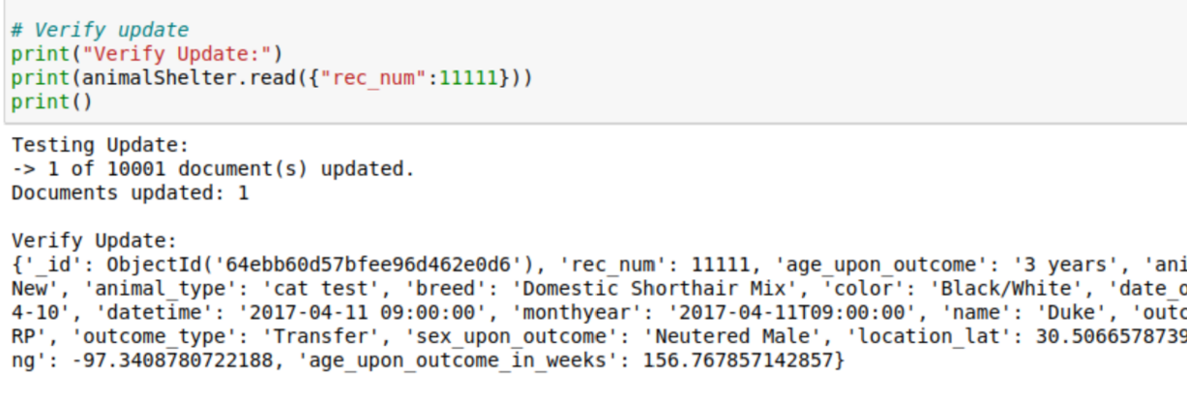



* + The following is the code-behind implementation of the update function:

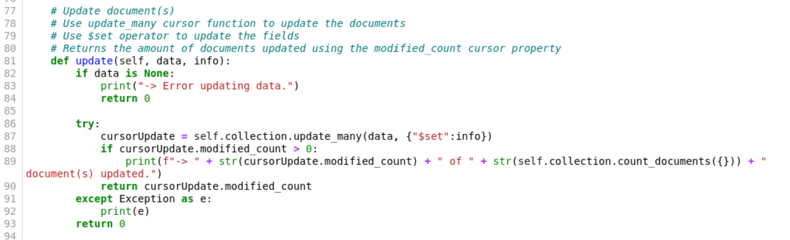

* Delete
  + Deleting from the database can be accomplished using JSON pair/value of document(s) you want to delete. An example of performing the delete is as follows. (Note: the return value of the delete operation is an integer value representing the number of documents that were deleted.)

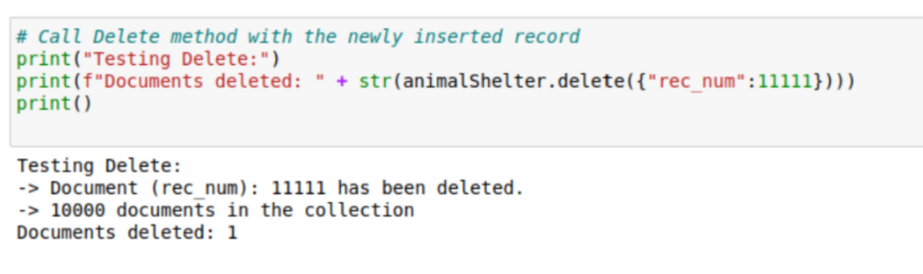

* + As a test, you can delete single records, or use a query that will delete multiple records. The result of the delete command above is a delete on a single document. We can verify the delete was successful by attempting a read on the record that was deleted:

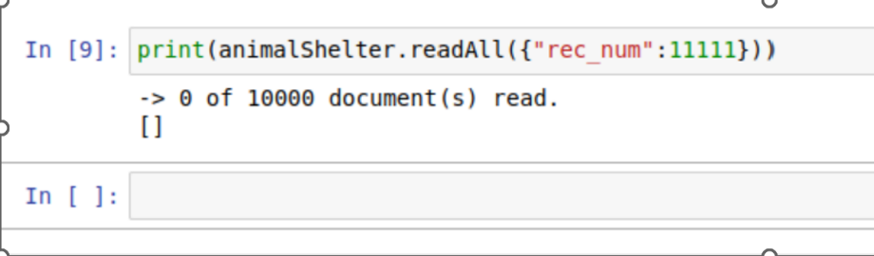

* + The following is the code-behind implementation of the delete function:

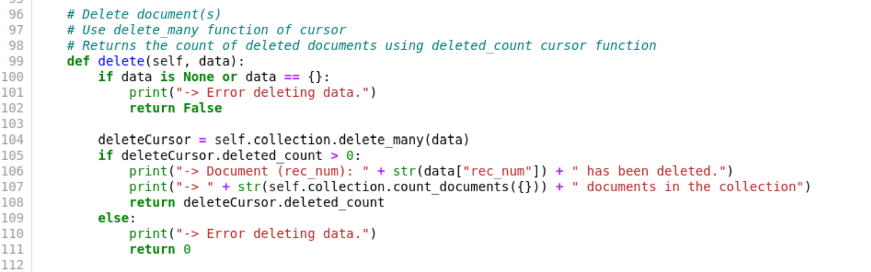

### Running the application

* Run the client file (Trimmer ProjectTwo MultiMap Update.ipynb) with the library file (CRUDLibWeek7.py) from an IDE of your choice and navigate to the URL listed in the output. You will be presented with a dashboard that looks like the screenshot following the sub-bullets:
  + Grazioso logo is clickable and takes the user to <https://www.snhu.edu>.
  + Data can be sorted and manually filtered on the datatable.
  + The data is paginated at five entries per page for the purpose of this report so that it is easier to see results in screenshots.
  + Use the radio buttons to quickly filter results based on five options.
    - The Reset button will output all records from the dataset.

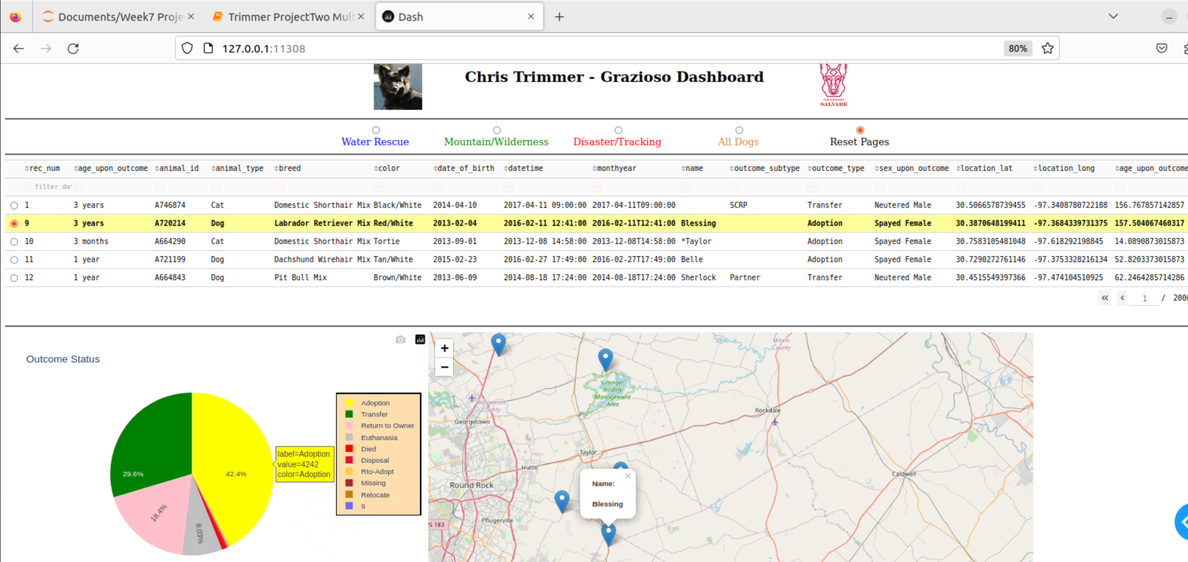

* + - The ‘All Dogs’ selection will filter out all records except for dogs.

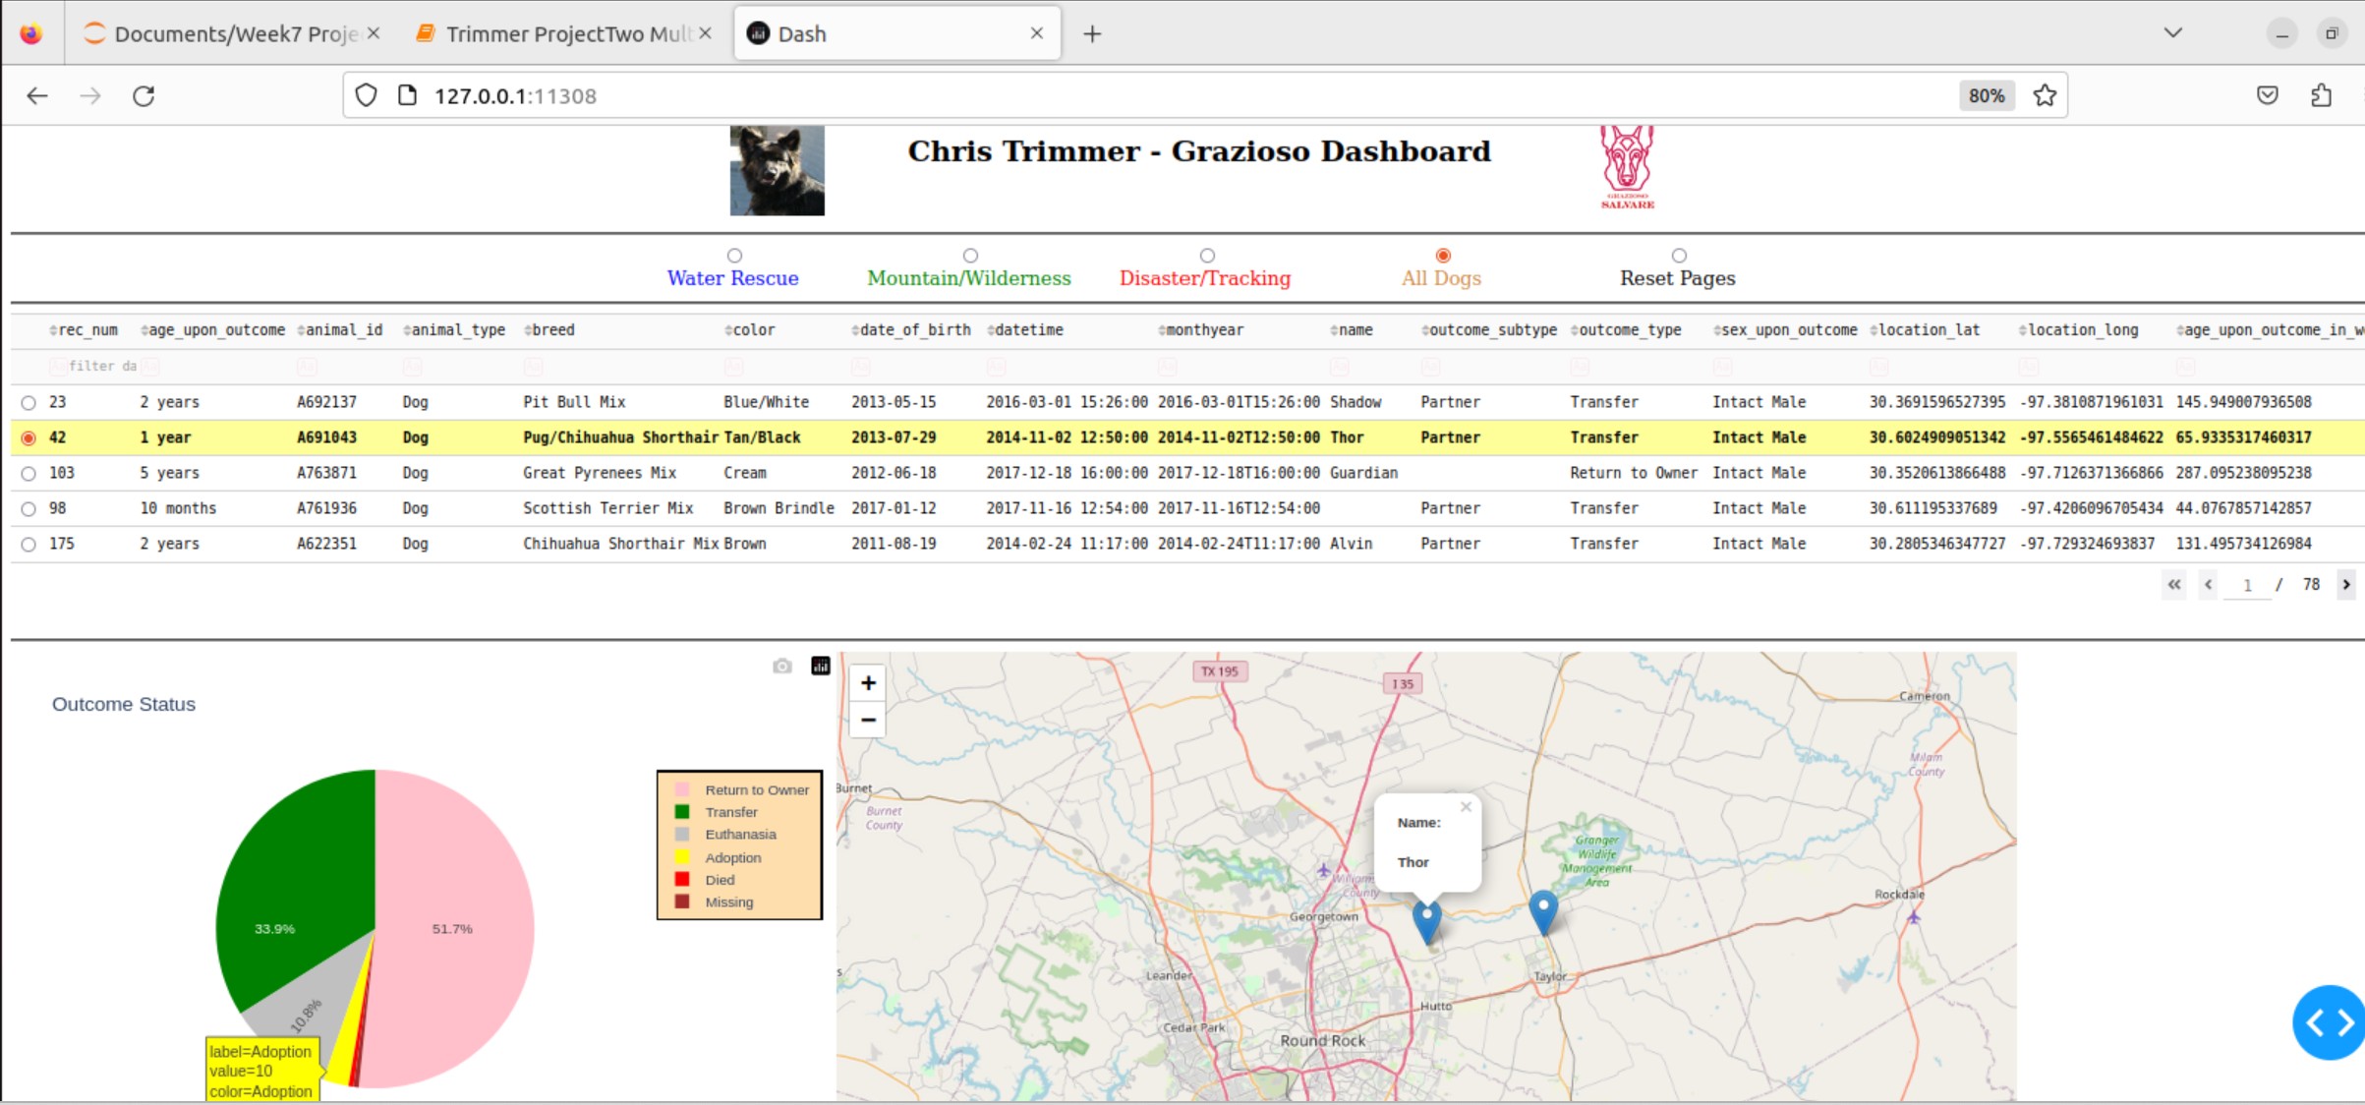

* + - The following is an example of filtering based on ‘Water’ rescue.

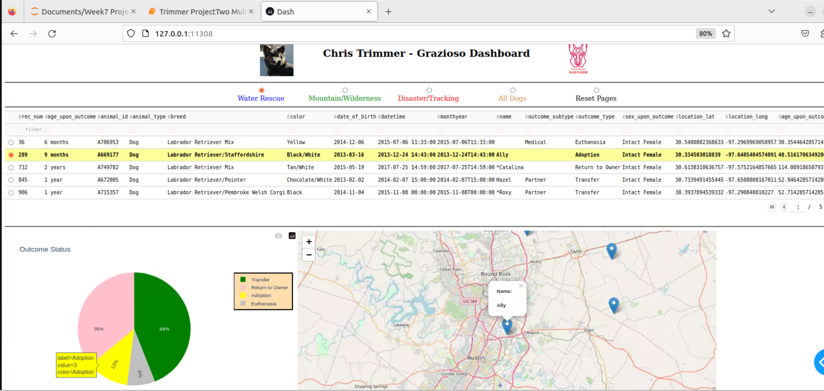

* + - The following is an example of filtering based on ‘Mountain/Wilderness’ rescue.

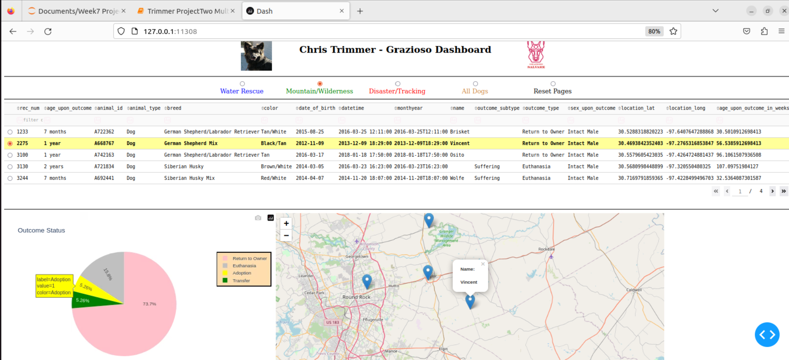

* + - The following is an example of filtering based on ‘Disaster’ rescue.

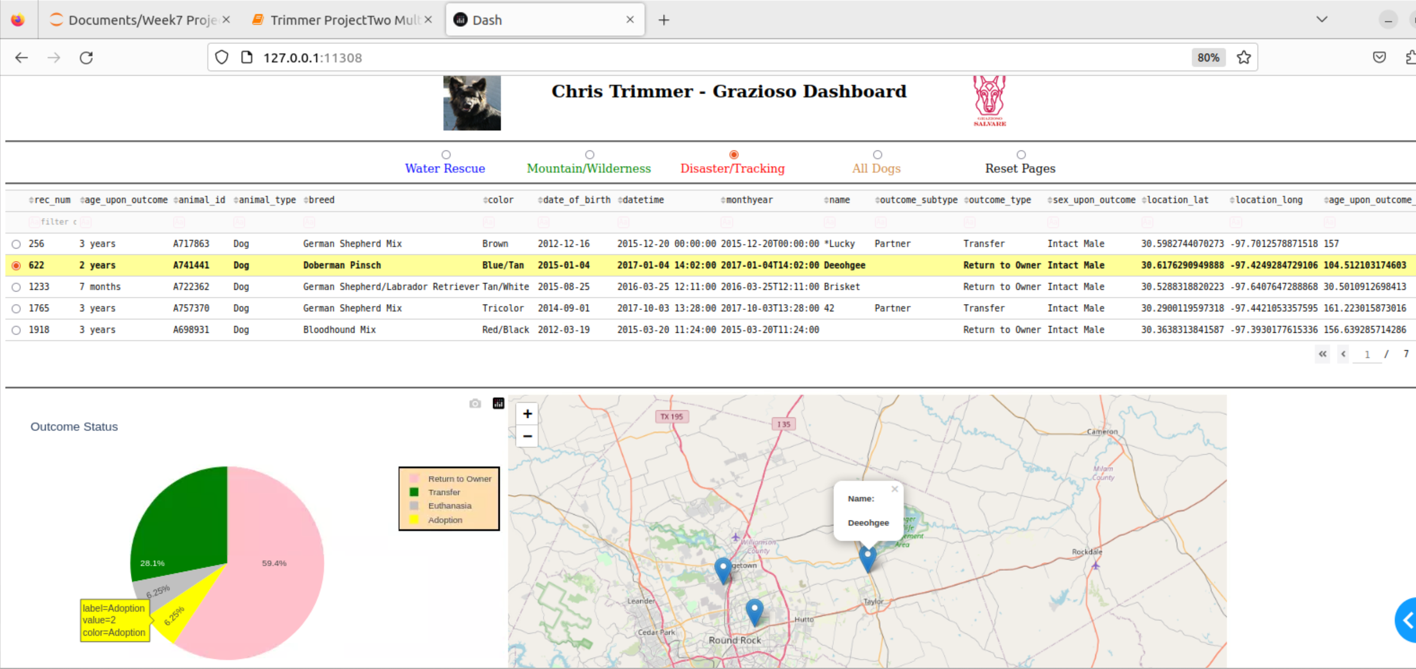

* + The pie chart is currently set to show the ‘Outcome Type’ for analysis. This was chosen so that Grazioso analysts can easily see which dogs are available for adoption, and any other status. The chart will update based on what is filtered in the table.

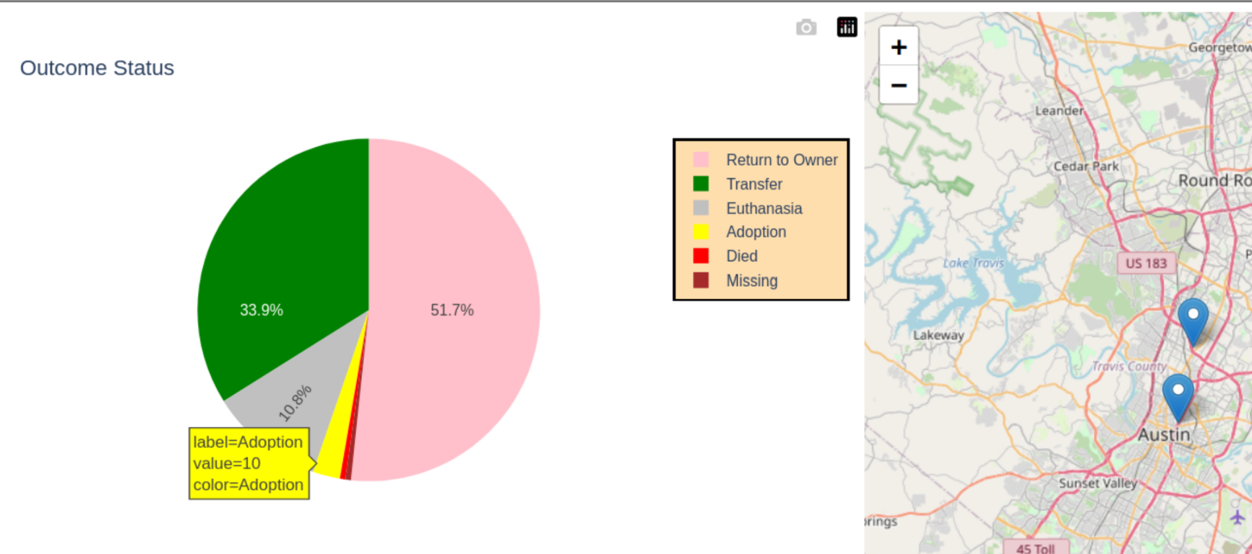

* + The geo-map displays the locations of dogs per each page of the result set. Moving to a different page will update the markers on the map.

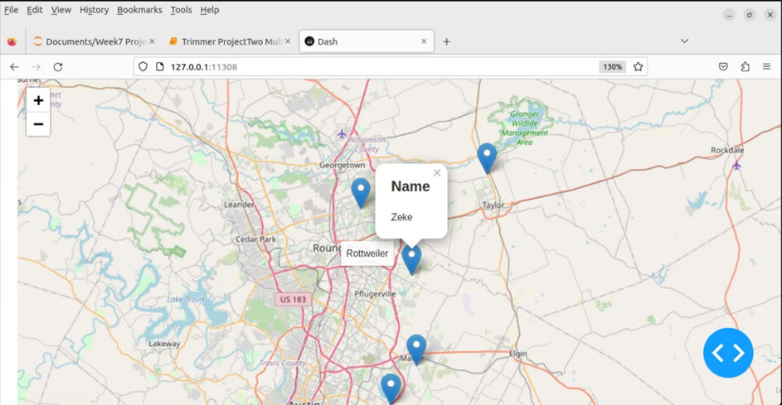

## Steps taken to complete the project

In addition to the technical steps described in the project setup section, I will also provide details and explanations of some of the backing code used to complete the project. I will first discuss my approach to completing the project. There are three main components to the application: The datatable, the map, and the pie chart. I used a divide-and-conquer approach to completing the project by dividing it up by the three main components. The following sections describe how I completed each component.

### The Datatable

* As shown in previous screenshots, the customer can view all 10,000 results without filtering (the results are displayed as five results per page. However, the customer can filter based on Water Rescue, Mountain/Wilderness, Disaster Tracking, and All Dogs. The customer can also select ‘Reset Pages’ which will reset to the default 10,000 records paginated at five results per page. The code for filtering on these options will be detailed in a section below.

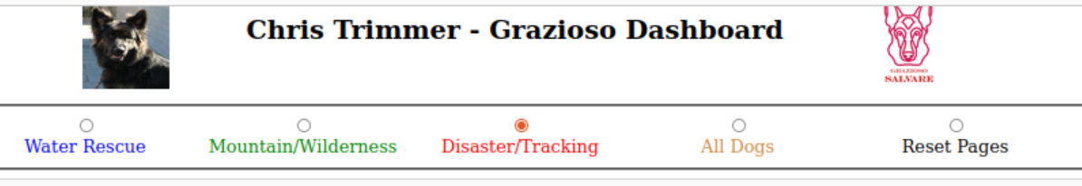

* The customer can also filter and sort. The screenshot below, we can see that by typing ‘Bat’ in the breed filter will select all records that match.

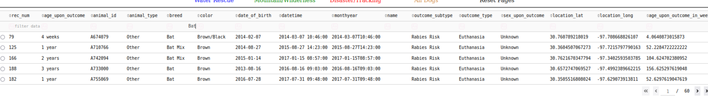

* The customer can also filter based two values. In the following example, we filter based on outcome_type, then age_upon_outcome to see youngest animals available for adoption:

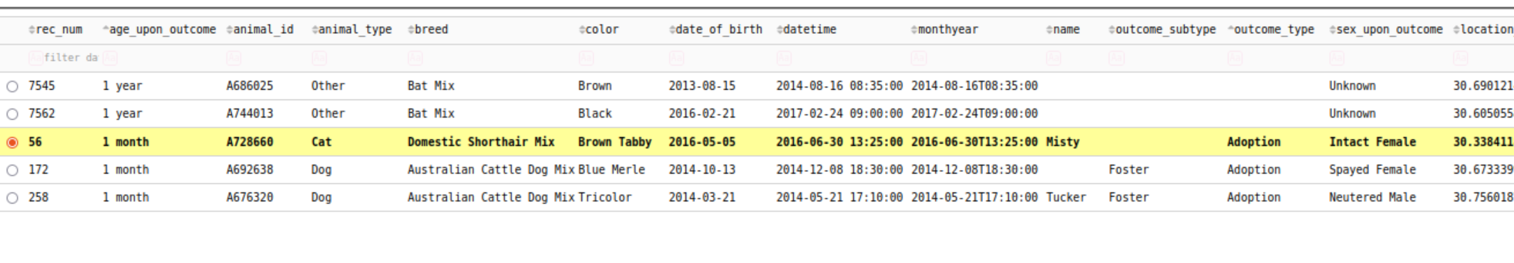

* The next screenshot shows sorting the result set based on record number. We see the first five results will be records one through five:

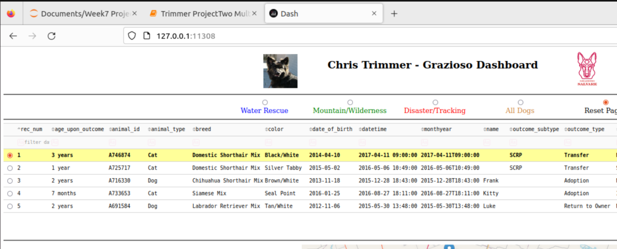

* The following is the code used to format the datatable:

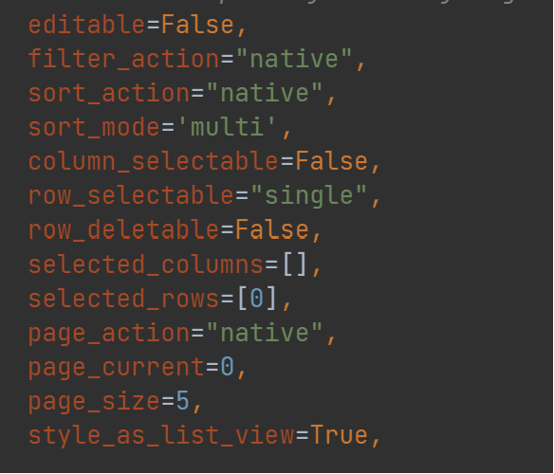

* Most of these settings are self-explanatory, but I will discuss a few of them. To get pagination to work, we use the page_action, page_current, and page_size settings. Altogether, these settings enable pagination, determine how many results are displayed per page, and sets the current page. The filter_action setting enables filtering. The sort_action and sort_mode enable sorting. Finally, we set the row_selectable setting to ‘single’ to enable only a single row to be selected at a time.

### The Map

* We have demonstrated screenshots of the map throughout this document. It shows markers for the five results that are in the current view port. When we hover over a marker, will see a tool tip that shows the breed. If the customer clicks on a marker, a pop-up will display the name of the animal that is selected. The map works by using a marker group that is passed to a layergroup which is displayed on the map. The following code shows the implementation:

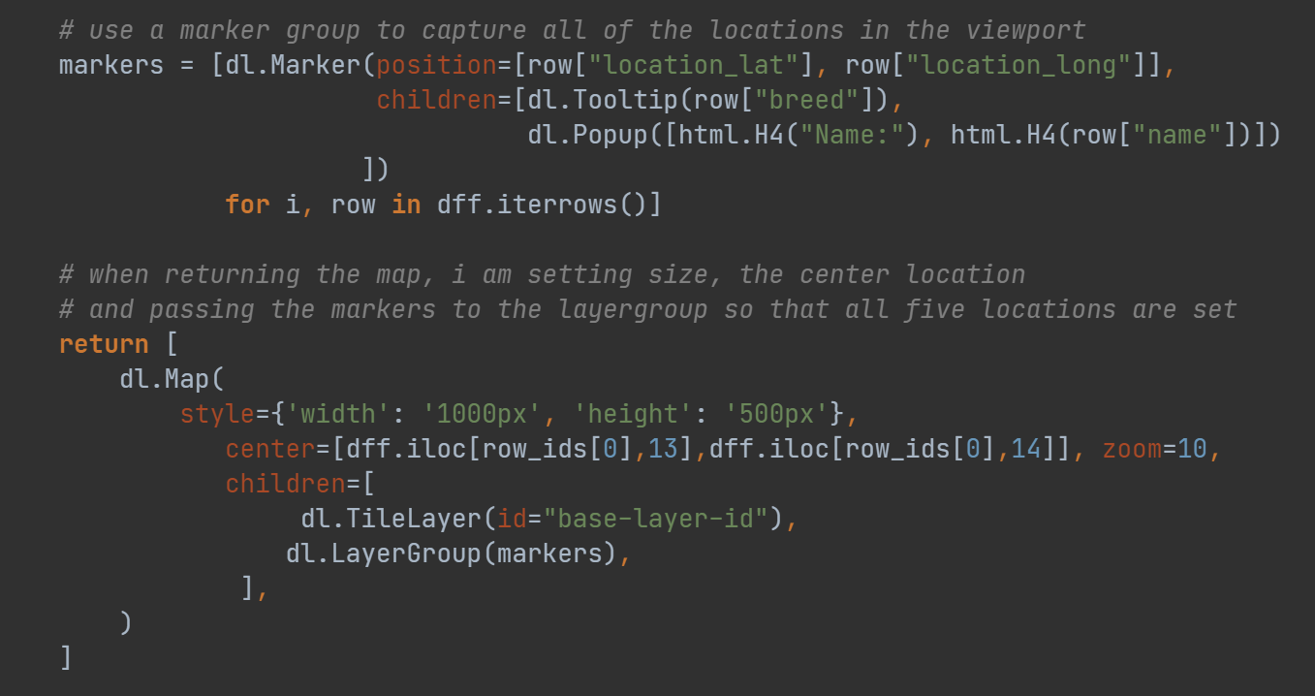

* The screenshot below is an example of the map displaying a result set:

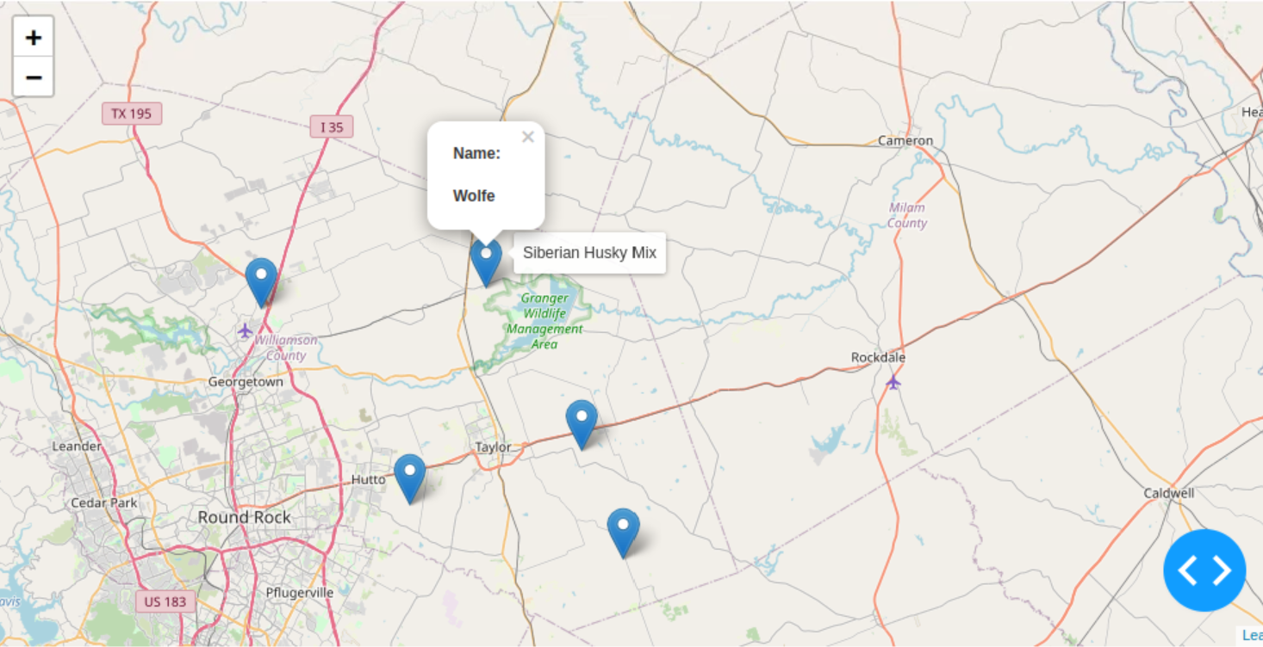

### The Pie Chart

* As described earlier in this document, I chose to use a pie chart to represent the outcome status of a chosen result set. I made quite a few changes to the default pie chart settings so that it looks more appropriate. The following screenshot shows the settings I used, and the next screenshot shows an example of the pie chart:

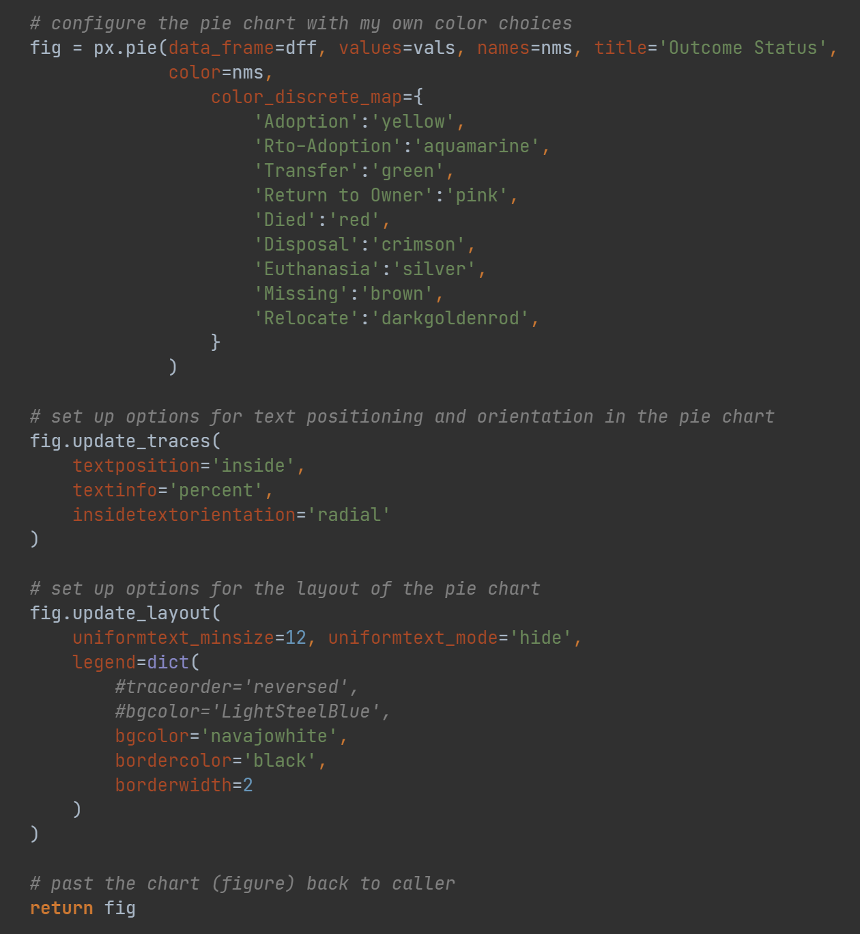

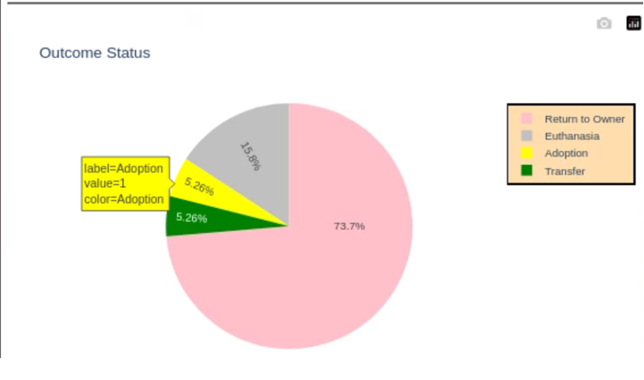

* The first thing to note in the code is how I set up the coloring of the pie chart. This is set up using the color_discrete_map multimap. We basically set up a color for each outcome status used in the datatable.
* Next, I wanted the values to be inside of each pie vector using percentage. These settings are completed in the update_traces function.
* Finally, it was important to get layout of the pie chart and the legend to look better. These settings are captured in the update_layout function. The legend settings are completed as a dictionary.

### Challenges and explanations

This section will detail some of the challenges experienced during the development of the project.

* Performance problems with highlighting. When I initially configured the project to highlight a selected row, the performance of the application was dramatically slow and laggy. One reason was because I was using derived_virtual_data as input. This caused the algorithm to loop through all 10,000 records to determine which row to highlight instead of looping through only the five active rows in the current view. Instead of using derived_virtual_data, I ended up using derived_viewport_data so that the algorithm only needs to loop through the current viewport of five active rows. This solution considerably improved performance. However, note that running this over the network will naturally incur lag, but it is much better in the latter solution. Below is a screenshot of the final algorithm for highlighting:

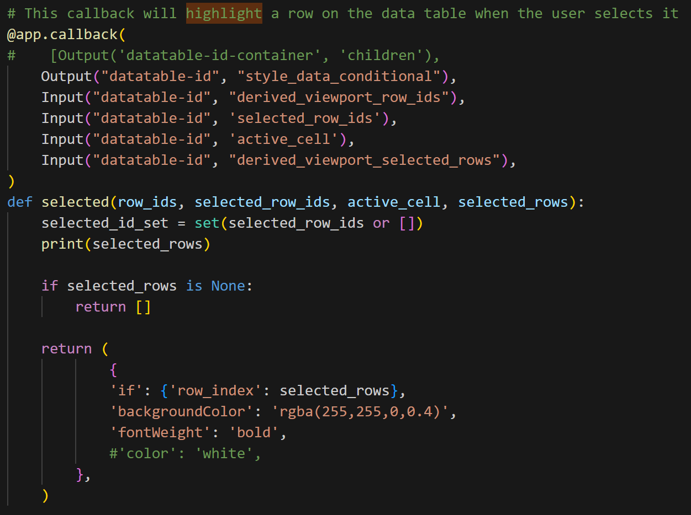

* There were ambiguities between the data formatting in the csv file compared to requirements listed in the specification document. One example is that ‘Newfoundland’ is listed as a breed, however there are no breeds that match that in the csv. However, there are breeds that contain ‘Newfoundland’ as part of their breed name (Newfoundland Mix, for example). Another example is the Chesapeake Bay Retriever breed listed in the specification table. To include these breeds in searching, we need to filter using ‘Chesa Bay Retr Mix’. (These are just two of various other examples).
  + I used inline regex compiling to implement filtering patterns in each category. The following are screenshots of the code:

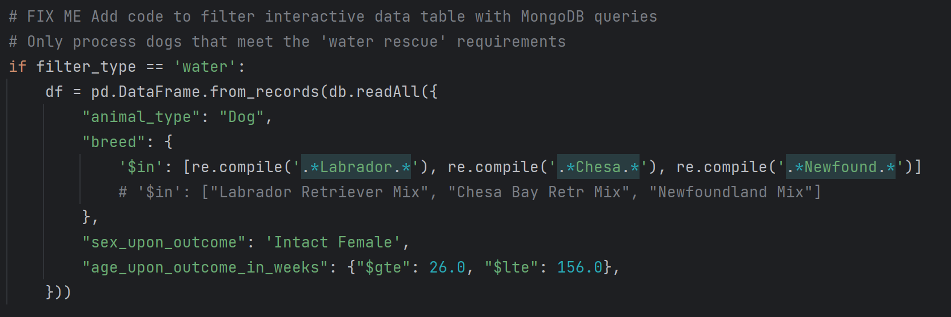

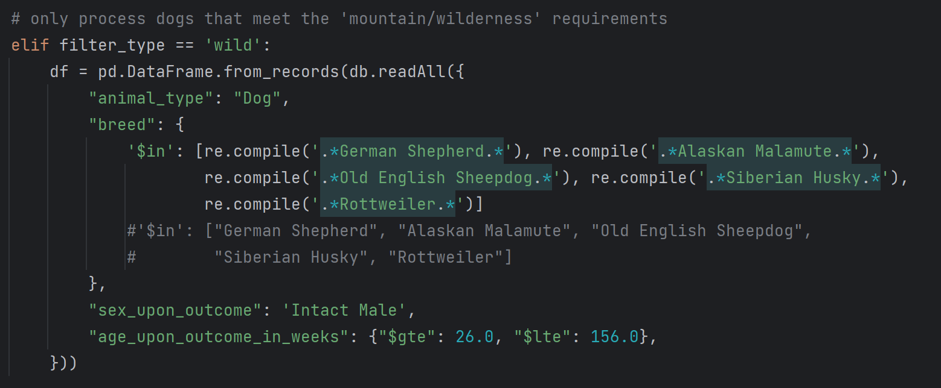

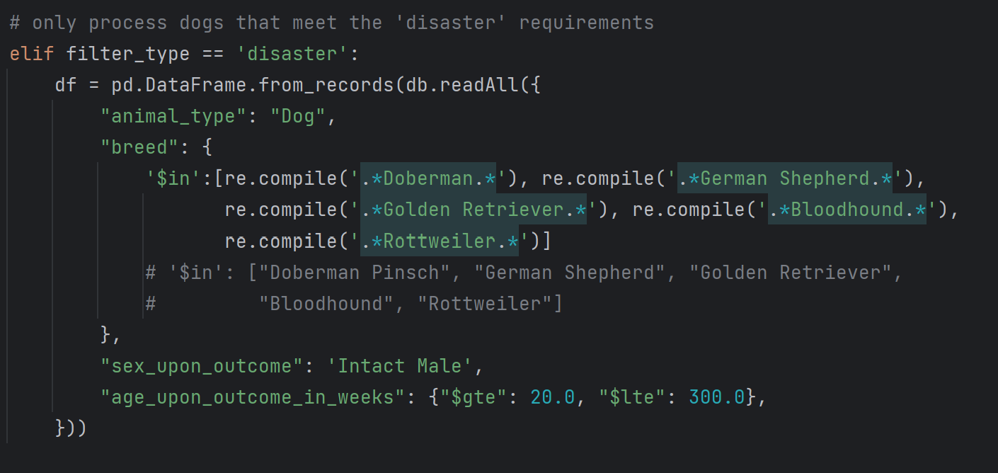

## Roadmap/Features (Optional)

The following is a list of future updates and proposed features:

* Add login functionality.

## Contact

Your name: Christopher Trimmer

## References

*Dash*

https://dash.plotly.com/dash-core-components/radioitems

https://plotly.com/python/legend/#legends-in-dash

*Leaflet*

https://www.dash-leaflet.com/

https://leafletjs.com/examples/layers-control/

*Pie Chart:*

https://plotly.com/python/pie-charts/

*Highlighting Rows:*

https://community.plotly.com/t/dash-datatable-press-on-cell-should-highlight-row/44076/2

https://dash.plotly.com/datatable/conditional-formatting

*Regex in PyMongo:*

https://stackoverflow.com/questions/19867389/pymongo-in-regex

*German Shepherd logo:*

https://commons.wikimedia.org/wiki/File:Eastern_Old_German_Shepherd_Dog_Kiara.jpg

https://creativecommons.org/licenses/by-sa/4.0/

Eastern Old German Shepherd Dog Kiara.jpg

by: Karel Adriaan (May 8, 2018)

*Grazioso Logo:*

Provided in CS340 Course Material